1. Write a program to print the number of vowels and number of consonants in the given statement and which is maximum

Program: def count_vowels_and_consonants(statement):

vowels = "aeiouAEIOU"

num_vowels = 0

num_consonants = 0

for char in statement:

if char.isalpha():

if char in vowels:

num_vowels += 1

else:

num_consonants += 1

return num_vowels, num_consonants

def main():

statement = "This is a sample statement for counting vowels and consonants."

num_vowels, num_consonants = count_vowels_and_consonants(statement)

print(f"Number of vowels: {num_vowels}")

print(f"Number of consonants: {num_consonants}")

if num_vowels > num_consonants:

print("Vowels are more than consonants.")

elif num_consonants > num_vowels:

print("Consonants are more than vowels.")

else:

print("Vowels and consonants are equal.")

if __name__ == "__main__":

main()

Output:

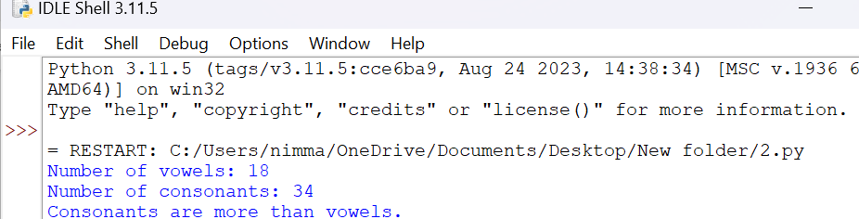

1. Program to print number of words in a line and number of lines in a para

Program:

def count_words_and_lines(paragraph):

lines = paragraph.splitlines()

num_lines = len(lines)

num_words_per_line = [len(line.split()) for line in lines]

return num_words_per_line, num_lines

def main():

paragraph = """This is the first line.

This is the second line with more words.

And this is the third line."""

num_words_per_line, num_lines = count_words_and_lines(paragraph)

print(f"Number of lines: {num_lines}")

print("Number of words per line:")

for i, count in enumerate(num_words_per_line, start=1):

print(f"Line {i}: {count} words")

if __name__ == "__main__":

main()

Output:

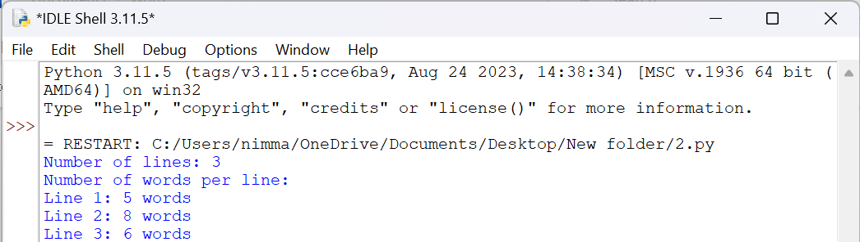

1. Program to find number of sentences starts with &quot;B&quot;

Program:

def count_sentences_starting_with_b(text):

sentences = text.split('. ')

count = sum(1 for sentence in sentences if sentence.strip().startswith('B') or sentence.strip().startswith('b'))

return count

def main():

text = """Bright skies are ahead.

Be ready for the new challenges.

Sometimes things can get tough.

But staying positive is key."""

count = count_sentences_starting_with_b(text)

print(f"Number of sentences starting with 'B': {count}")

if __name__ == "__main__":

main()

Output:

